National University of Computer and Emerging Sciences



Lab Manual 04

Computer Organization and Assembly Language Lab

|  |  |
| --- | --- |
| Course Instructor | Ms. Tazeem Haider |
| Lab Instructor (s) | Mr. Gullsher Ali Chaudhary  Ms. Nimra Abbas |
| Section | L1& L2 |
| Semester | Fall 2022 |

Department of Computer Science

FAST-NU, Lahore, Pakistan

**Chapter 4 - Bit Manipulations**

**New Instructions:**

|  |
| --- |
| CLC ; Clear Carry Flag C=0  STC ; Set Carry Flag C=1  CMC ; Complement Carry Flag |

**Shift and Rotate Instructions”**

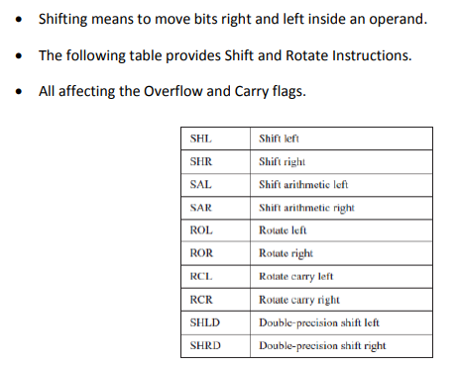

**Problems**

1. Write a program to swap every pair of bits in the AX register i.e. swap bit no 0 with bit no 1, bit no 2 with bit no 3 and so on.

**Sample Run:**

|  |  |
| --- | --- |
| AX before Swap | **1011 0010 0101 1101** |
| AX after Swap | **0111 0001 10 101110** |

1. Write a program that subtracts two 64-bit numbers.
2. Calculate the number of one bits in BX and complement an equal number of least significant bits in AX. HINT: Use the XOR instruction.

**Sample Run:**

|  |  |  |  |
| --- | --- | --- | --- |
| **Initial value of BX** | **Total No of 1 Bits in BX** | **Initial value of AX** | **AX after Complementing 7 least significant bits** |
| 1011 0001 1000 1001 | 7 | 1010 1011 1**010 0101** | 1010       1 1**101 1010** |